Register for an account with mLab with this link and then sign in.  
<https://mlab.com/welcome/?gclid=CIv31sm3udICFV61wAodDewEcw>

**Creating online mongo database:**

1. From the home tab, to the right of MongoDB Deployments section click on “Create New”
2. Choose Google as the cloud provider
3. Make sure the region selected is: “Google’s Central Region (us-central1)”
4. From plan, select “Single-node”
5. Choose the free option which is “Sandbox (shared, 0.5 GB) FREE”
6. After selecting the Sandbox option, the MongoDB version will be **3.2.x(MMAPv1)**
7. Provide a database name, the name has to be in lower case.

I gave the name of: **easyaspidb**

1. Click on “Create new MongoDB deployment”
2. You have now created the online database for the application easy as pi. And it should look something like the image below:

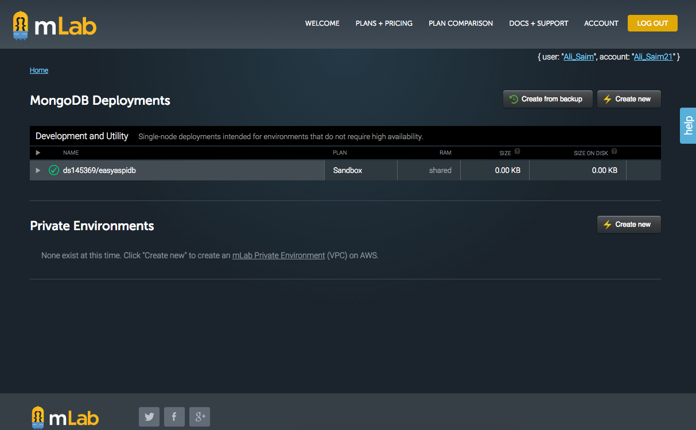

Figure 1: Creating the Online Database that will be used for the Application

After creating the online database, we need to add a user to this database. This user be an admin which has privileges of reading, writing and deleting from the database, and with the user’s information we can apply CRUD operations to the stored data.

**Creating a User for the database**

1. Click on the name of the database, in our case it is: **easyaspidb**
2. Select the “users” tab and click on “Add database user” button
3. A window will open and ask for the following information:

Database username*:

Database password*:

Confirm password*:

I provide the following information for these requirements:

Database username*: **easyaspiadmin**

Database password*: **pass123**

Confirm password*: **pass123**

1. Make sure that “Make read-only” is **NOT** selected, then click “CREATE”

A user has now been added to the database, using this user’s information we can makes changes to the records. It should now look like the image below:

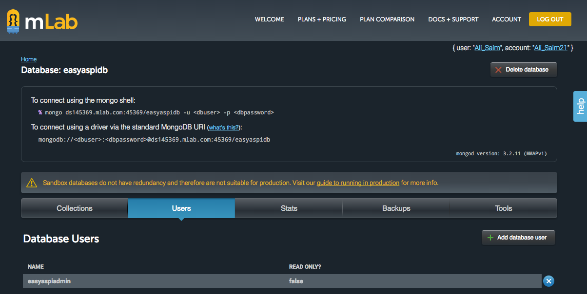

*Figure 2: Creating a User for the Database*

**Tools Installations Needed to Connect to Backend (mLab Database)**

Tool Name: **NodeJS**

Download and install this software from: <https://nodejs.org/en/download/>

After installation of this software to make sure that it is working properly, you need to:

1. Open a terminal window
2. Type “**node –v”** (without the quotation marks)
3. You should NOT get any errors, it should tell you what version of the software you have downloaded and installed on your computer, in my case it says: **v6.10.0**
4. If you are getting any error messages:
   1. You did not type **node –v** correctly in the terminal window
   2. You did not install this program correctly and you need to install it again.

Here it how it should look like:

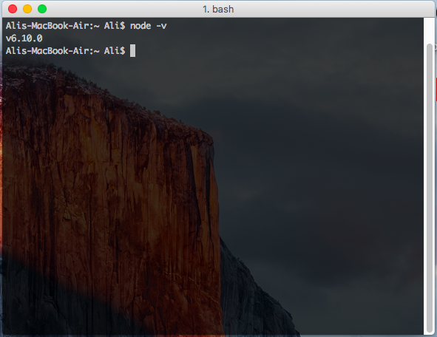

Figure 3: Checking if NodeJS was Installed Successfully

Tool Name: **Node Package Manager (npm)**

This tool comes with NodeJS

To check if you have **npm** installed correctly on your computer you need to open a terminal window and type **npm –v.**

You should get something like:  
**3.10.10** or maybe a new or older version it does not matter.

If you are getting any error message, it might be because of:

1. You did not type the correct command in the terminal window. The correct command is **npm -v**
2. You installed **NodeJS** incorrectly and need to reinstall this program with proper configuration settings.

What is should look like if you have installed NodeJS and Node Package Manager (which is included in the installation of NodeJS) correctly.

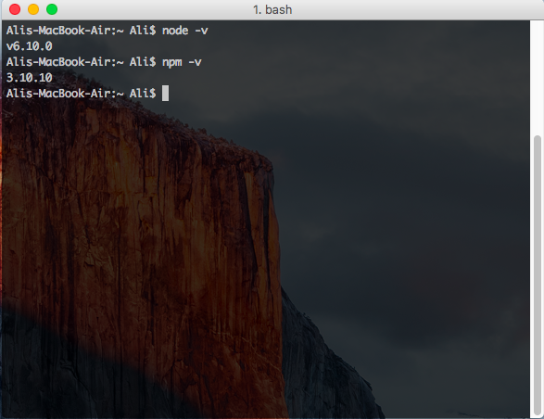

Figure 4: What is should look like on the terminal windows if NodeJS and npm have been installed properly.

Tool Name: **MongoDB**

Download and install this software from this link: <https://www.mongodb.com/download-center?jmp=nav#community>

This is a NoSQL database, the same program as mLab, except the databases created using MongoDB will be on localhost. We will be using this program to do most of the testing of our application’s database components locally. If tests are passed, we can then replace the localhost database(MongoDB) with the cloud database(mLab).

**Installation for Windows:**

1. In Local Disk(C): you need to create a new folder called “**data**”
2. In side “**data**” you need to create another folder called “**db**”
3. Go this link: <https://www.mongodb.com/download-center?jmp=nav#community>
4. Select windows operating system:
5. Select “Windows Server 2008 64-bit without SSL support x64”
6. Click download and complete the installation process.

To confirm if you have successfully installed and configured MongoDB on your computer, open a terminal window and type: **“mongod”** if you are getting any error messages, then you did not install the software with the correct configuration settings or the path environments variables are missing or is incorrect.

This is what is should look like if you have installed MongoDB correctly on your windows computer.

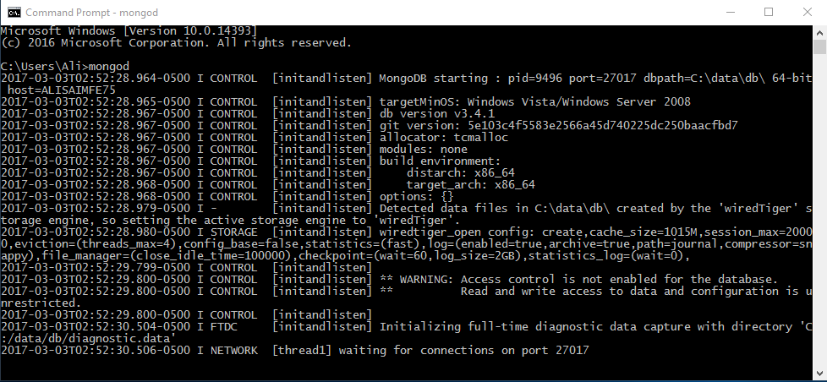

**Installation for Mac:**